**9. ReactJS-HOL**

Create a React Application named “cricketapp” with the following components:

**App.js**

import React from 'react';

import { players } from './playersData';

import { allIndianPlayers, IndianTeam } from './indianPlayersData';

import {

  ListOfPlayers,

  ScoreBelow70,

  OddPlayers,

  EvenPlayers,

  ListOfIndianPlayers

} from './components';

function App() {

  const flag = false;

  if (flag) {

    return (

      <div>

        <ListOfPlayers players={players} />

        <hr />

        <ScoreBelow70 players={players} />

      </div>

    );

  } else {

    return (

      <div>

        <h1>Indian Team</h1>

        <OddPlayers players={IndianTeam} />

        <hr />

        <EvenPlayers players={IndianTeam} />

        <hr />

        <ListOfIndianPlayers players={allIndianPlayers} />

      </div>

    );

  }

}

export default App;

**components.js**

import React from 'react';

export function ListOfPlayers({ players }) {

  return (

    <div>

      <h1>List of Players</h1>

      {players.map((item, index) => (

        <div key={index}>

          <span>Mr. {item.name}</span>: <span>{item.score}</span>

        </div>

      ))}

    </div>

  );

}

export function ScoreBelow70({ players }) {

  return (

    <div>

      <h1>List of Players Having Scores Less than 70</h1>

      {players

        .filter(player => player.score < 70)

        .map((item, index) => (

          <div key={index}>

            <span>Mr. {item.name}</span>: <span>{item.score}</span>

          </div>

        ))}

    </div>

  );

}

export function OddPlayers({ players }) {

  const [first, , third, , fifth] = players;

  return (

    <div>

      <h1>Odd Players</h1>

      <div>First: {first}</div>

      <div>Third: {third}</div>

      <div>Fifth: {fifth}</div>

    </div>

  );

}

export function EvenPlayers({ players }) {

  const [, second, , fourth, , sixth] = players;

  return (

    <div>

      <h1>Even Players</h1>

      <div>Second: {second}</div>

      <div>Fourth: {fourth}</div>

      <div>Sixth: {sixth}</div>

    </div>

  );

}

export function ListOfIndianPlayers({ players }) {

  return (

    <div>

      <h1>List of Indian Players Merged</h1>

      {players.map((player, index) => (

        <div key={index}>Mr. {player}</div>

      ))}

    </div>

  );

}

**indianPlayersData.js**

const T20Players = ["Sachin1", "Dhoni2", "Virat3", "Rohit4", "Yuvraj5", "Raina6"];

const RanjiTrophyPlayers = ["First Player", "Second Player", "Third Player", "Fourth Player", "Fifth Player", "Sixth Player"];

export const allIndianPlayers = [...RanjiTrophyPlayers, ...T20Players];

export const IndianTeam = T20Players;

playersData.js

export const players = [

  { name: "Jack", score: 50 },

  { name: "Michael", score: 70 },

  { name: "John", score: 40 },

  { name: "Virat", score: 95 },

  { name: "Elizabeth", score: 61 },

  { name: "Jadeja", score: 84 },

  { name: "Rohit", score: 68 },

  { name: "Dhoni", score: 100 },

  { name: "Sachin", score: 101 },

  { name: "Yuvraj", score: 75 },

  { name: "Raina", score: 45 },

];

**Output:**

**When Flag=true**

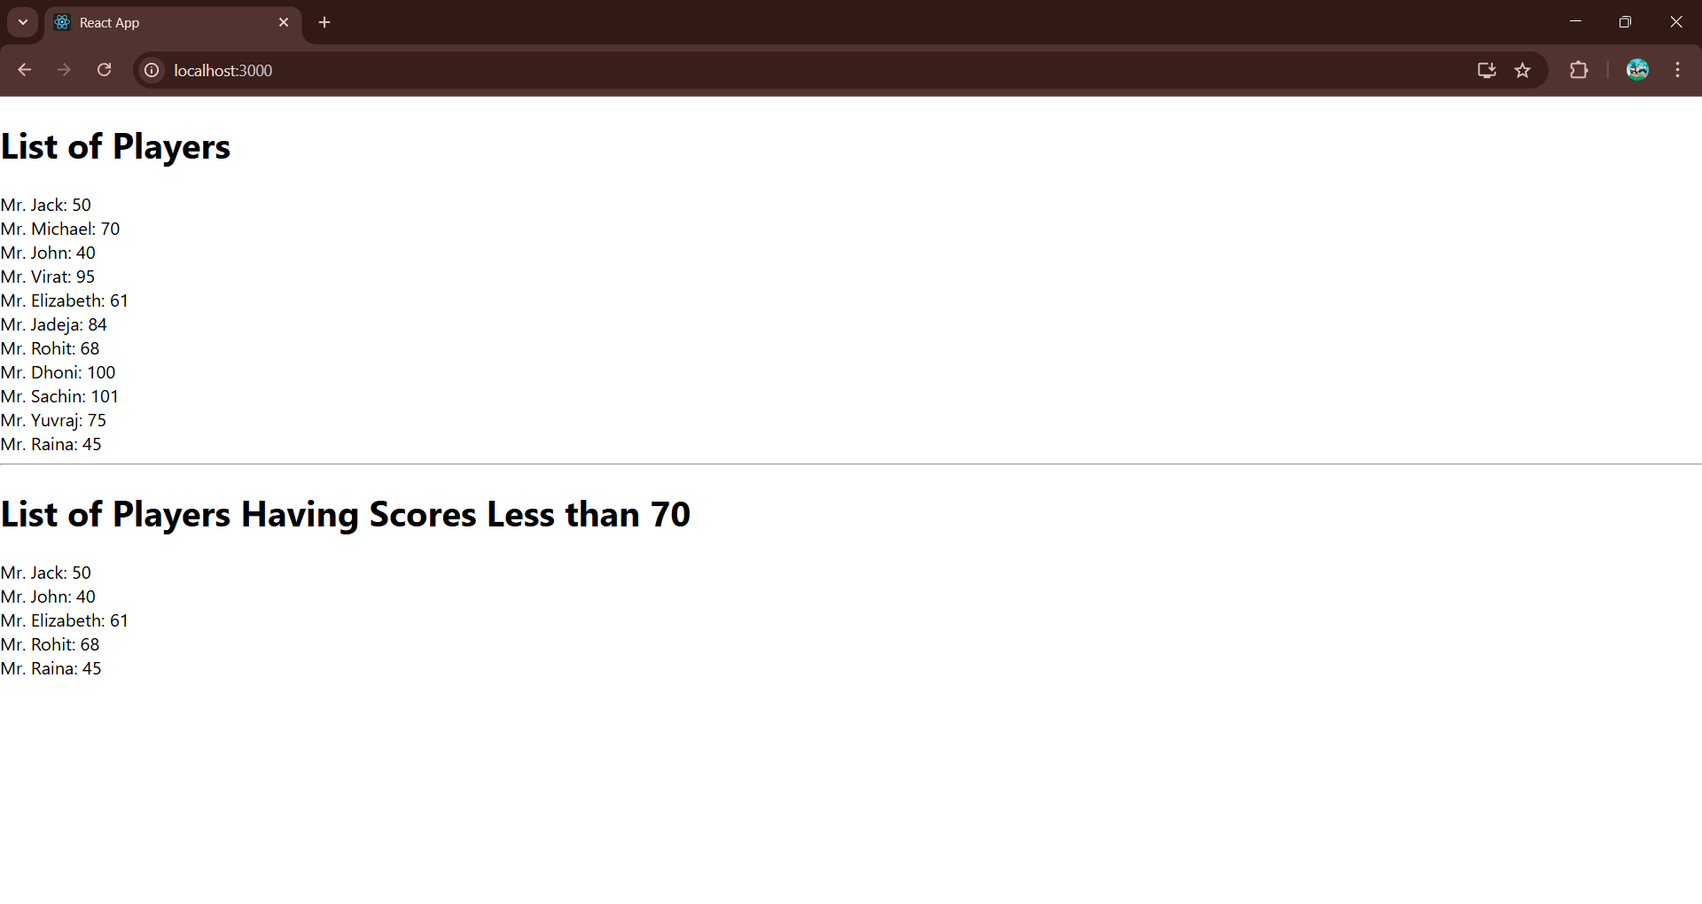

**When Flag=false**

